**A picture containing clipart

Description generated with very high confidence**

KUBERNETES INSTALLATION

DevOps Certification Training

[**support@intellipaat.com**](mailto:support@intellipaat.com)

**+91-7022374614**

**US: 1-800-216-8930(Toll Free)**

**INSTALLING KUBERNETES**

**Steps for Both Master and Slave**

**Step 1:** Run the following commands for installing kubeadm as root

$ apt-get update

$ apt-get install docker.io

$ apt-get update && apt-get install -y apt-transport-https curl

$ curl -s https://packages.cloud.google.com/apt/doc/apt-key.gpg | apt-key add -

$ cat <<EOF >/etc/apt/sources.list.d/kubernetes.list

deb https://apt.kubernetes.io/ kubernetes-xenial main

EOF

$ apt-get update

$ apt-get install -y kubelet kubeadm kubectl

**Steps for Kubernetes Master**

**Step 1:** Initialize kubeadm using the following command:

$ kubeadm init –apiserver-advertise-address=<ip-address-of-master> --pod-network-cidr=192.168.0.0/16 --ignore-preflight-errors=NumCPU

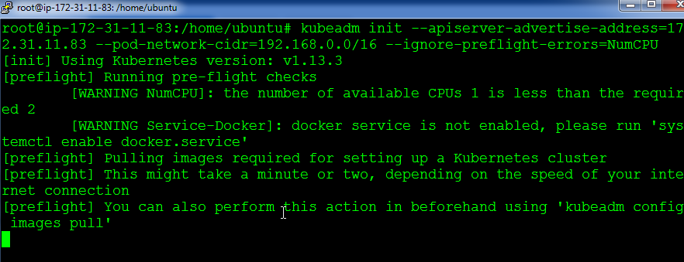

**Step 2:** In the output of the previous command, you will get a command, take this command and run it in the slave

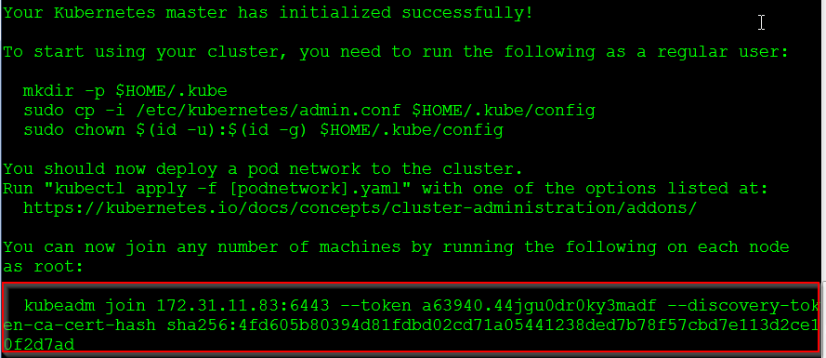

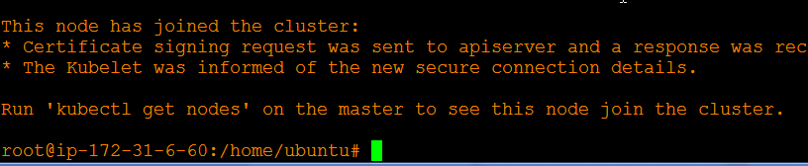

**Step 3:** On the master, exit to the normal user, and execute the following commands:

$ mkdir -p $HOME/.kube

$ sudo cp -i /etc/kubernetes/admin.conf $HOME/.kube/config

$ sudo chown $(id -u):$(id -g) $HOME/.kube/config

**Step 4:** Next, let’s install the network plugin. Execute the following commands:

$ kubectl apply -f https://docs.projectcalico.org/v3.3/getting-started/kubernetes/installation/hosted/rbac-kdd.yaml

$ kubectl apply -f https://docs.projectcalico.org/v3.3/getting-started/kubernetes/installation/hosted/kubernetes-datastore/calico-networking/1.7/calico.yaml

Step 5: The previous command will take some time to take effect. After 4-5 mins, try the following command, if both the nodes are in the ready state, Installation is successful!

$ kubectl get nodes

